**General Objective:**

Upon completion of this lab, the student will be able to:

1. Calculate voltages, currents, gains, slew rate, common mode rejection ratio for differential amplifier circuits.
2. Construct, measure, and demonstrate the proper use of the test equipment.

**References:**

* Theory notes
* First Year Text & Lab books
* [MPQ3904](https://drive.google.com/file/d/1lcsOYYijrEcRzkrqCgofw1wja_IBliMH/view?usp=sharing)

**Check-Off Sheet:**

* [Check-Off Sheet](https://drive.google.com/file/d/1hlakEMEVNWf4GoSC9AhN_-OrqpxCimJc/view?usp=sharing)

**Specific Objectives:**

Notes.

* 1. Theory Notes
  2. First year Text & Lab books

1. 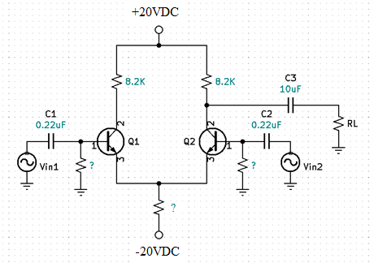Differential Amplifier
   1. For the above Diff-Amp circuit, Optimize and show the following calculations.
      1. all DC biasing voltages.
      2. Single Ended Input (open loop) gains and waveforms.
      3. Common Mode gains and waveforms.
      4. Differential Mode gains and waveforms.
      5. **Instructor Check**
   2. Construct and measure previously calculated values.
   3. Draw measured waveforms.
   4. Annotate data in a Table and analyze the calculated vs. measured data and waveforms.
   5. **Instructor Check**
   6. Replace the tail resistor with a constant current source and repeat steps a-c.
   7. Compare the differential and common mode gains of the tail resistor circuit to the constant current source circuit.
   8. **Instructor Check**
2. Design a Single Ended Inverting Differential Amplifier with variable gain control.
   1. Show circuit schematic and all calculations.
   2. Measure and document waveforms and gains.
   3. Measure and document Voutmaxp.
   4. Measure and document frequency response.
   5. **Instructor Check**
3. Design a Single Ended Non-Inverting Differential Amplifier with variable gain control.
   1. Show circuit schematic and all calculations.
   2. Measure and document waveforms and gains.
   3. Measure and document Voutmaxp.
   4. Measure and document frequency response.
   5. **Instructor Check**
4. Complete Conclusion and submit completed Check-Off sheet and Lab writeup in Moodle.